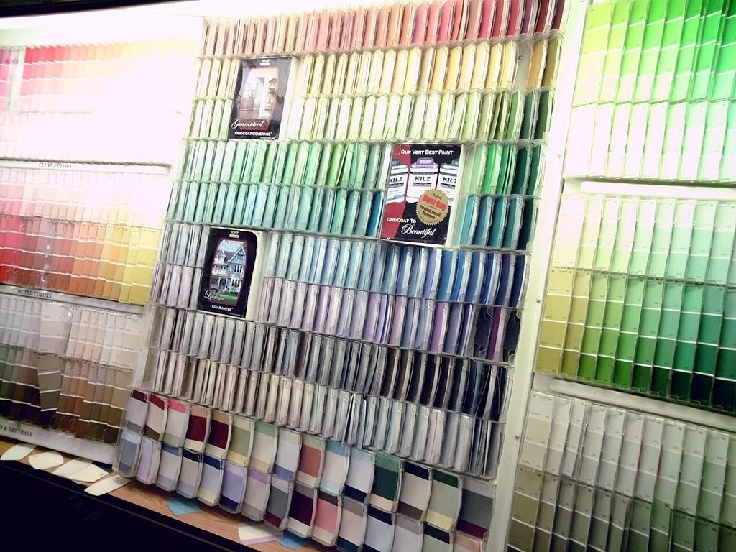

**420**

**-**

**436**

**-**

**VA: System Devemopment (Section 01)**

**Teacher: Alex Steinheuser vilvert**

**Student:**

**Theodore, Tsimiklis**

**(2065694)**

**Jiahui, Xia**

**(2044092)**

**George, Athanasatos**

**(1951431)**

**Andrei, Marinescu**

**(1972210)**



**Vanier**

**College**

**Computer Science Department**

Table of Contents

MONDAY 24, JANUARY 2022(1:30PM - 2:15PM) 3

TUESDAY, JANUARY 2022(3:05PM - 3:45) 3

THURSDAY 27, JANUARY 2022(12:40 - 1) 4

MONDAY 7, FEBRUARY 2022(12:00-14:00) 4

TUESDAY 8, FEBRUARY 2022(14:00-16:00) 4

THURSDAY 10, FEBRUARY 2022(12:00-14:00) 5

MONDAY 14, FEBRUARY 2022(11:30-14:10) 5

TUESDAY 15, FEBRUARY 2022(14:00-16:00) 5

THURSDAY 17, FEBRUARY 2022(12:00-14:00) 6

MONDAY 21, FEBRUARY 2022(11:30-14:10) 6

TUESDAY 22, FEBRUARY 2022(14:00-16:00) 6

THURSDAY 24, FEBRUARY 2022(12:00-14:00) 7

MONDAY 28, FEBRUARY 2022 7

TUESDAY 1, MARCH 2022(14:00-16:00) 7

THURSDAY 3, March 2022(12:00-14:00) 7

Monday 7, MARCH 2022(11:30 – 14:30) 8

# MONDAY 24, JANUARY 2022(1:30PM - 2:15PM)

Today we discussed about potential clients, we still need to decide if we are going to use HTML, CSS, JavaScript or C# for windows forms. Aswell, we need to figure out if we are going to be making a web-based app or an actual GUI app we are just waiting on the client's response. We posted each other's schedules to plan meetings on discord. We started up an agenda to help us with meetings so we can know what to talk about

# TUESDAY, JANUARY 2022(3:05PM - 3:45)

We have discovered a site to plan out our clients website(bubble). This site is meant for us to make an outline for our project. We continued to discuss possible clients but we have one that might be available. We began to plan ahead into the future so we can be prepared.

# THURSDAY 27, JANUARY 2022(12:40 - 1)

We out Found client (Sam Assi) and confirmed that they are 100% our client. We are talking about what we can do for the client. We know we will be building a website so we need to figure out what exactly our client wants done. We will be starting our project plan at the next meeting.

# MONDAY 7, FEBRUARY 2022(12:00-14:00)

Today we reformatted our entire agenda and team journal to make it look nicer because where it stood it wasn’t as good as we could have made it look. We also started working on the deliverable since that's due to present on Thursday and continued to work on a project plan.

# TUESDAY 8, FEBRUARY 2022(14:00-16:00)

Today we created the document for the first deliverable, we finalized the information for the MS Project. Then we discussed more about how the project will be formatted and how we will need to follow the given schedule set up by MS Project as best as possible.

# THURSDAY 10, FEBRUARY 2022(12:00-14:00)

Today, Theo (group leader) presented the first deliverable, we received some criticism from the teacher and corrected them according to what is best. We then talked about how to display the steps for this project so we decided on MS Planner.

# MONDAY 14, FEBRUARY 2022(11:30-14:10)

Nothing productive, working on other stuff and will start the second deliverable next class.

# TUESDAY 15, FEBRUARY 2022(14:00-16:00)

Today we were told details about the 3rd deliverable such as the flowchart, the UML diagram… Once that was over, we used the last few minutes of the class to separate the work evenly and to set up a due time so that we can review before the presentation that we have on Thursday.

# THURSDAY 17, FEBRUARY 2022(12:00-14:00)

Today, Andrei (group leader) presented the second deliverable to the class. We listened to the other group's presentation and what the teacher had to say about us and the other presenters had to say to help us out.

# MONDAY 21, FEBRUARY 2022(11:30-14:10)

We attended Alex’s presentation, then worked on quiz 4 since it is necessary to be as knowledgeable as possible to successfully accomplish the third deliverable. We then discussed how the workload would be separated and how to work on the UML and flowchart.

# TUESDAY 22, FEBRUARY 2022(14:00-16:00)

We attended Alex’s presentation, for a more in depth explanation on flowchart,

UML as well as the user case information that we have to include for this deliverable.

We then worked as a group, drawing the UML that we then drew on draw.io.

# THURSDAY 24, FEBRUARY 2022(12:00-14:00)

There were no presentations this week so Alex presented what he needed to tell us. We then went back to draw the flowchart as well as the UML. Afterwards, we separated the work between ourselves for the user case to do during the weekend.

# MONDAY 28, FEBRUARY 2022

We did not attend class since Alex canceled since his kids have March break.

# TUESDAY 1, MARCH 2022(14:00-16:00)

Alex presented the class diagram to complete for this deliverable. We then drew the class diagram on the board to have a general overview of what needs to be accomplished online. After, we talked about what else needs to be done and will work more on the next class.

# THURSDAY 3, March 2022(12:00-14:00)

There were no presentations this week so Alex presented what he needed to tell us. We discussed and draw the class diagram for deliverable 3.

# Monday 7, MARCH 2022(11:30 – 14:30)

Today is the presentation for team leader to present our deliverable 3. Then we continue work on deliverable and update the MS project.

snip for project plan

